**Convert Process Builder into Flow**

**Prepared By**

Florentino Aryo Widyantoro,

Technical Consultant

Steps:

1. Query a process builder using this query:  
   Select id, MasterLabel, Status, versionNumber from flow where MasterLabel = Process_Builder_Label' . Mark ‘Use Tooling API’ as checked.  
   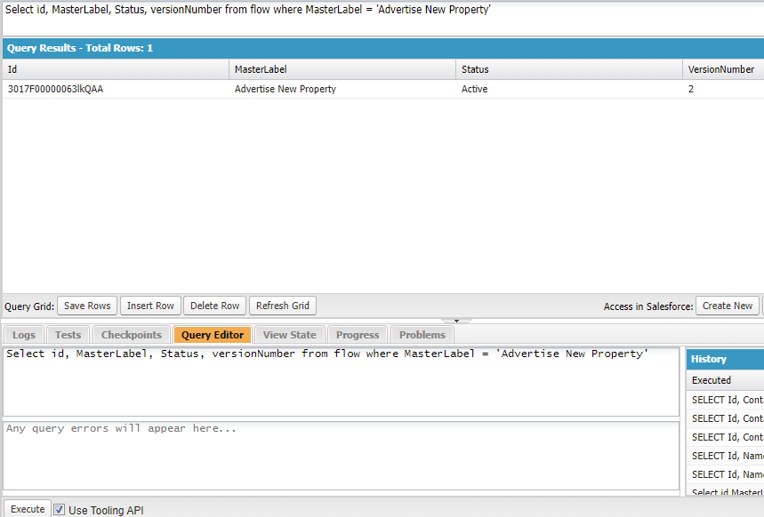
2. Copy the result Id from the results.
3. Open any flow in Flow Builder then replace ‘flowid’ value from browser’s address bar with Id from step #2, press Enter.  
   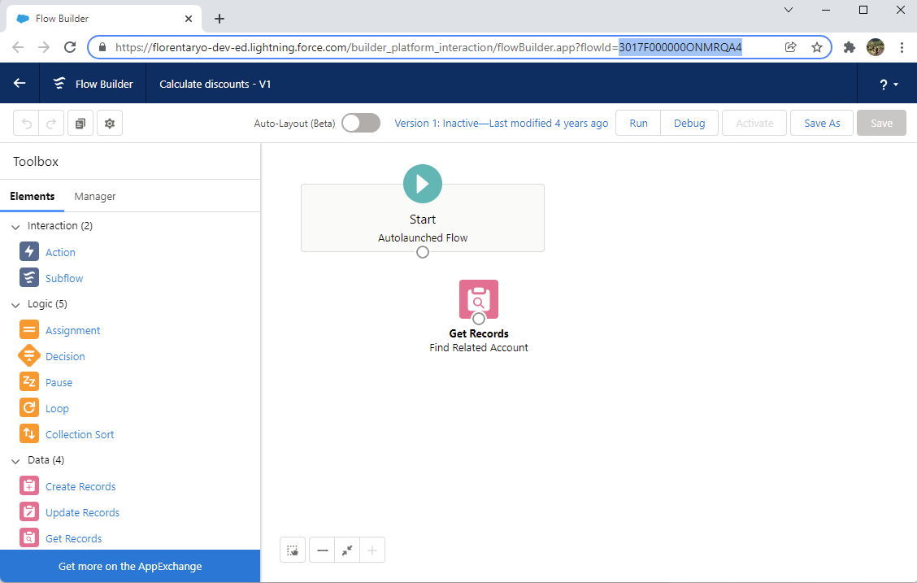
4. Click ‘Save As’ then save as New Flow
5. Fill some name
6. Click ‘Advanced’, then change Type picklist value into ‘Record Triggered Flow’
7. Click ‘Save’
8. Configure Start, fill Object  
   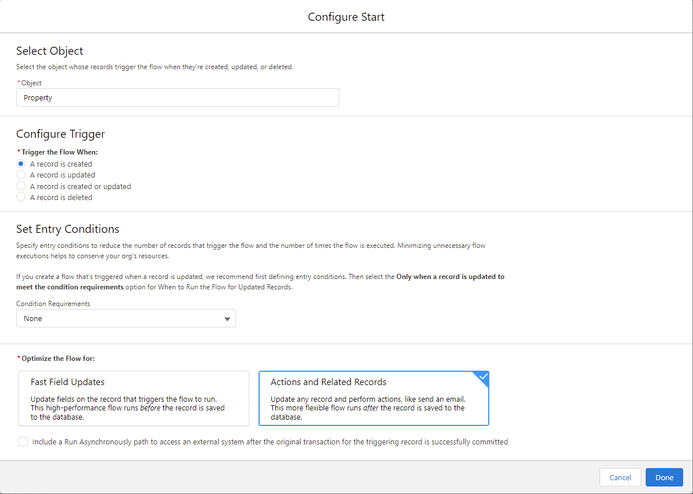
9. Configure Trigger and any other changes you needed.
10. Click ‘Done’, your new Flow is ready.

References:

https://developer.salesforce.com/docs/atlas.en-us.api_tooling.meta/api_tooling/tooling_api_objects_flow.htm